**Wine Reviews**

**Objective:** Building a model to predict the ideal wine based on the adjectives that user selected to describe the taste and feel.

**Model: Naïve Bayes**

1) Exploring data

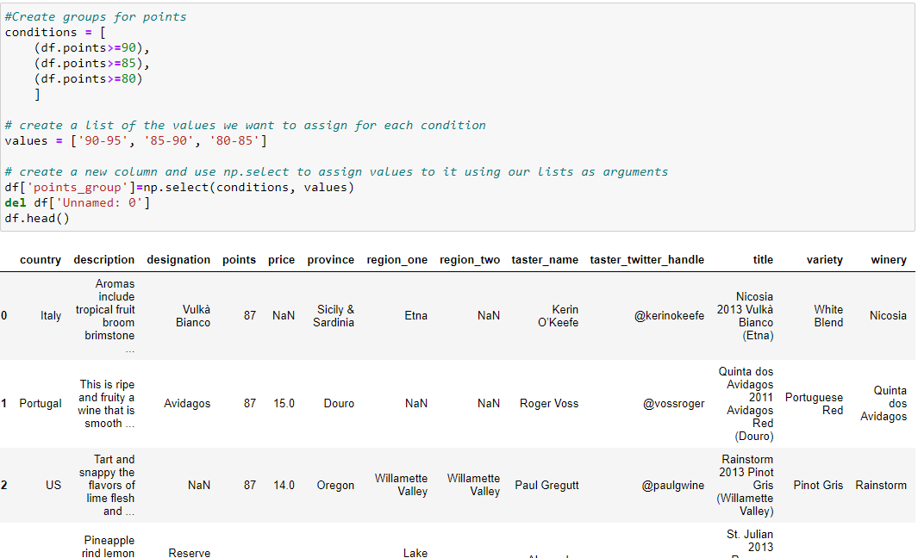

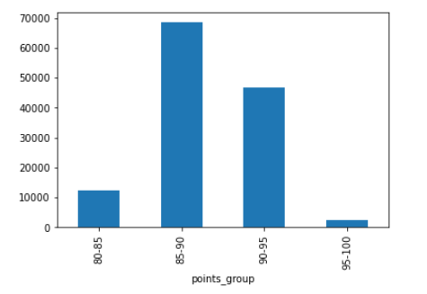

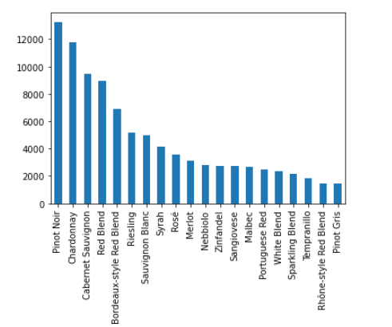

2) Data Pre-processing

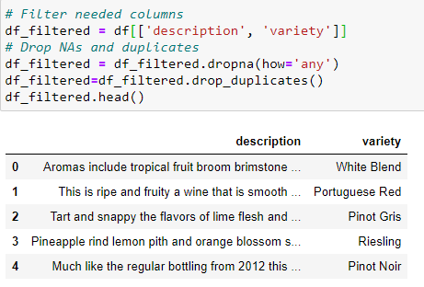

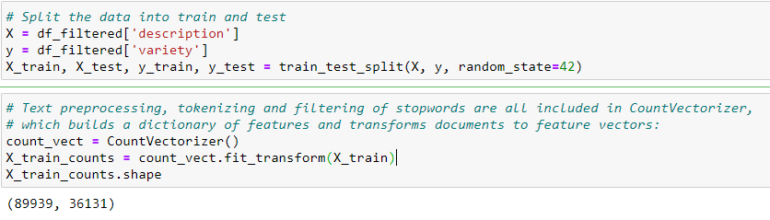

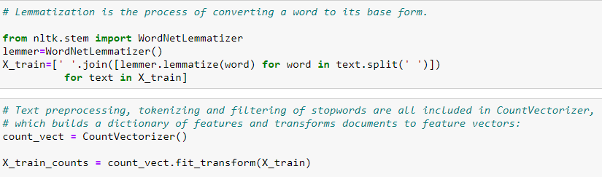

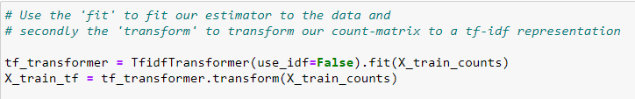

3) Train the model: Multinomial vs Complement Naïve Bayes



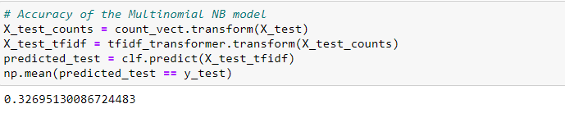

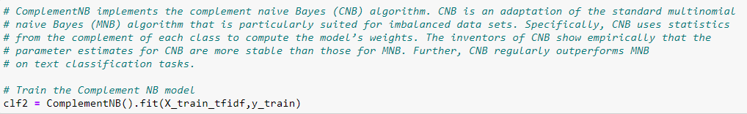

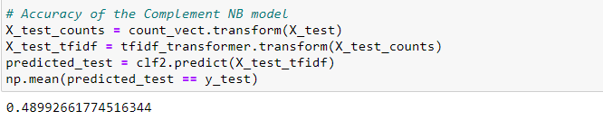

4) Save the model: Complement NB

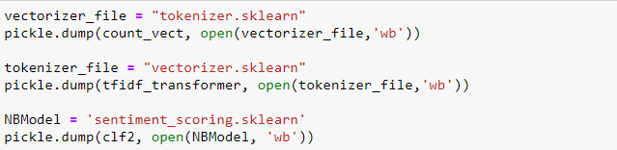

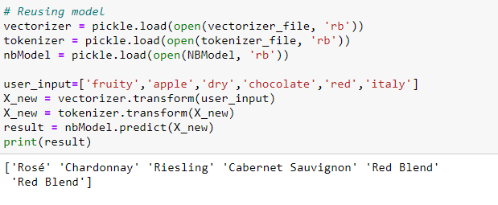

**Model: Deep Learning**

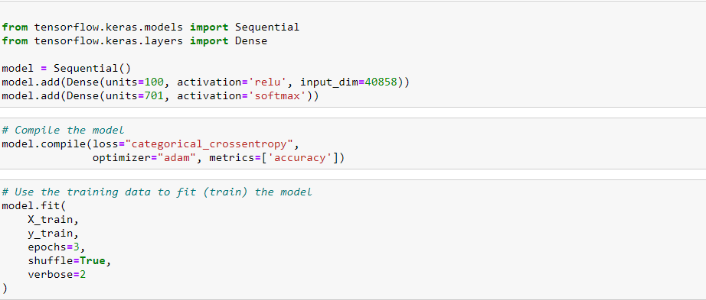

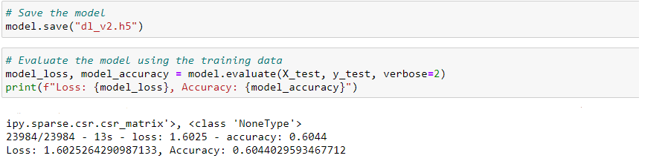

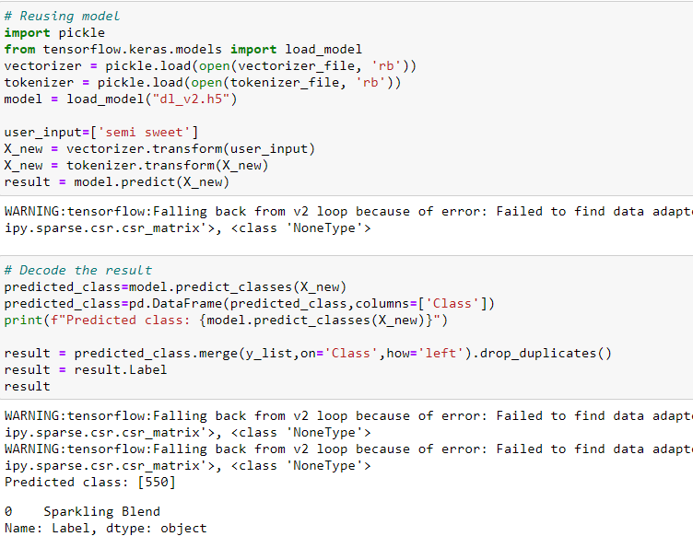

**Notes:**

* Data pre-processing to bring the text into a form that is predictable and analyzable:
  + Count Vectorizer: Text preprocessing, tokenizing and filtering of stopwords
  + Transformer: Transform our count-matrix to a tf-idf representation “Term Frequency times Inverse Document Frequency”.
* Models: Multinomial NB, complement NB, deep learning. Deep learning performed the best among these models, this might be because of the complexity of the dataset.
* Challenge: Because of the complexity and size of data, deep learning worked very slowly. That’s why we could not test as many variations as we want to find the best parameters. We could have used hyperparameter tuning to find the highest accuracy.
* Assumption: We trained the model based on wine selection and reviews of 19 tasters and assumed the results were a general fact.